***Assignment 2.6:***

Q a:  
**import** java.util.*;

**public** **class** acad {

**public** **static** **void** main(String args[]){

Scanner s=**new** Scanner(System.***in***);

System.***out***.println("enter starting value a:");

**int** a =s.nextInt();

System.***out***.println("enter ending value b:");

**int** b =s.nextInt();

System.***out***.print("even numbers are:");

**int** c=a;

**while**(a+1<=b)

{**if**(a%2==0)

{ System.***out***.print(a+" ");

}

a++;

}a=c;

System.***out***.print("\nodd numbers are:");

**while**(a+1<b)

{**if**(a%2!=0)

{ System.***out***.print(+a+" ");

}

a++; }}}  
OUTPUT:  
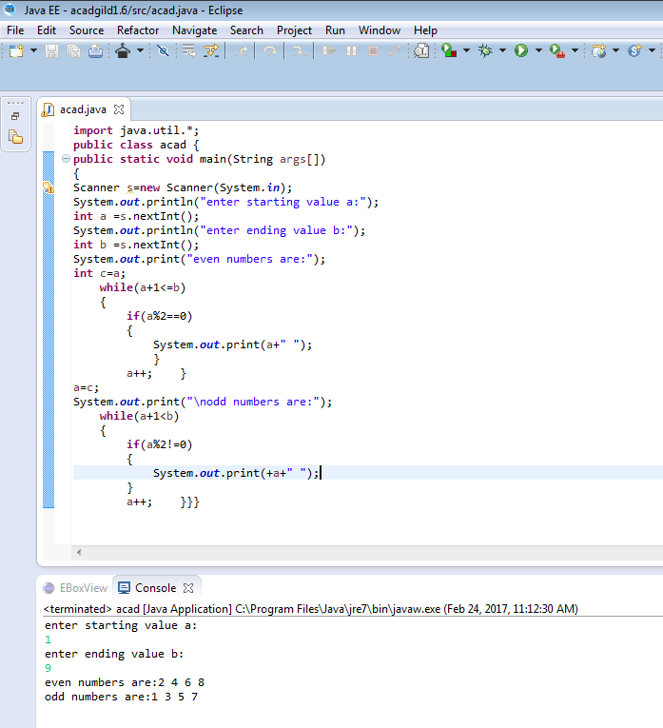

Q b:  
**import** java.util.*;

**public** **class** acad {

**public** **static** **void** main(String args[])

{

Scanner s=**new** Scanner(System.***in***);

System.***out***.println("enter the a value");

**int** a =s.nextInt();

**int** i;

**for**(i=1;i<=10;i++)

{

System.***out***.println(a+"."+i+"="+(a*i));

} }}  
  
  
OUTPUT:  
  
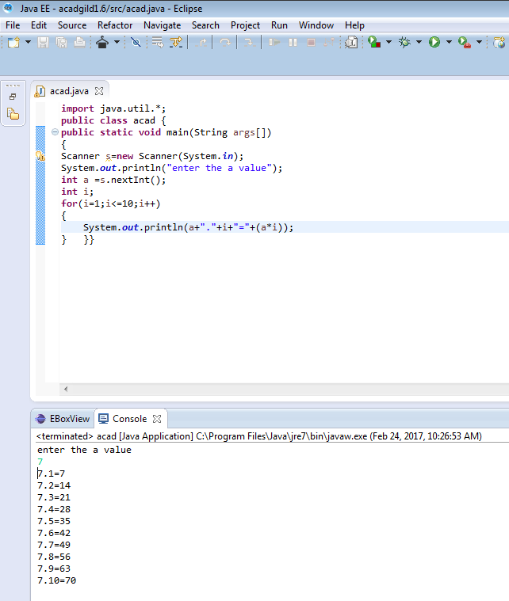

Q c:   
**import** java.util.*;

**public** **class** acad {

**static** **int** sum(**int** x,**int** y, **int** z){

**return** x+y+z;}

**static** **int** sum(**int** x,**int** y){

**return** x+y;}

**public** **static** **void** main(String[] args) {

Scanner s=**new** Scanner(System.***in***);

System.***out***.print("enter the a value:- ");

**int** a=s.nextInt();

System.***out***.print("enter the b value:- ");

**int** b=s.nextInt();

System.***out***.println("Sum is:- "+*sum*(a,b));

}}

OUTPUT:  
  
